Parsons
Parsons Constructors Inc.
100 West Walnut• Pasadena, California 91124 • (626) 440-3000 • Fax: (626) 440-2516

July 21, 2016

Tom Lemmon
Business Manager
San Diego County Building and Construction Trades Council
3737 Camino Del Rio South, Suite 202
San Diego, California 92108

Subject: San Diego Unified School District Project Stabilization Agreement (PSA) PSA Pre-job Conference- Southland Electric Inc.
DATE OF EVENT: Wednesday July 27th 2016
Time: 1:00-3:00pm School Name: Various
Project Description: i21 IDIQ Installation Classroom Technology
Contract#: CZ-17-0079-08
Contract Amount: 628,010.00

Dear Mr. Lemmon,

The Southland Electric Inc. PSA Pre-job Conference for the Installation of i21 Classroom Technology Systems on an as needed basis, is scheduled for the above date and time.

The location of the Pre-job Conference is at the following:

PPO Training Room A
4860 Ruffner Street
San Diego, CA 92111

Please distribute this notice to all of the trades. If you have any questions, please contact my office at (858) 539-981

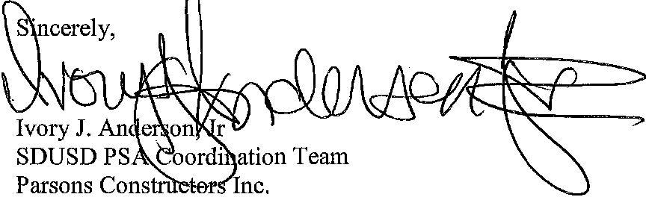

cc: George Harris III/SDUSD (gharris@sandi.net)

